# Assignment 1 – Kyle Mercer (09/09/2018)

**Due:** This assignment is due one week after the beginning of the term.

Answer the following questions to the best of your ability with or without consulting reference materials. When in doubt, make an intelligent guess. The goal is to stimulate thought, and to provide a yardstick against which you can compare your knowledge and way of thinking at the end of the term. Provide your answers in the space provided below each question.

1. Explain how a bicycle works. Does this have to do with navigation, or with guidance and control? Why do cyclists like lightweight wheels? What is the disadvantage of lightweight wheels? What does this have to do with the operation of a Segway scooter?

The operation of a bicycle, I think, requires a hint of navigation but more so guidance and control. When a human operates a bicycle, he or she performs navigation through path planning which involves data input through the eyes to calculate things such as distance, curve, incline of a path, etc. Guidance and control are tightly coupled when operating the bicycle. The operator uses multiple feedback control systems internally to keep the bicycle upright and stable, relying on the concept of angular momentum as the key to balance. In addition, other sources of input to the operator feed other internal control loops such as the vestibular system for balance as well as eyes, ears, and touch to determine approximate speed.

I think lighter weighted wheels give you an overall less mass in the entire system, allowing for faster acceleration and looser handling. However, heavier wheels add more mass to the overall system which can slow a rider’s acceleration, but also increase traction and ultimately provide better control.

1. Name ten stars and five constellations.

|  |  |
| --- | --- |
| Stars  - Sagittarius A * (my favorite)  - Northern Star  - The Sun  - Alpha Centauri A  - Alpha Centauri B  - Betelgeuse  - Calvera  - Aldebaran  - Rigel  - VY Canis Majoris | Constellations  - Sagittarius  - Ursa Major  - Orion  - Cygnus  - Gemini |

1. If the moon rises at 6 PM on Monday, when does it rise on Tuesday?

According to <https://www.almanac.com/content/when-will-moon-rise-tonight> the moon rises approximately 50 minutes after the time it did the day before. Therefore, the moon would rise at about 6:50PM on Tuesday.

1. What is UTC? How does it differ from GPS time?

UTC stands for Universal Time Coordinated. This is the time that is gradually adjusted to include “leap seconds” as a way to stay in line with the Universal Solar Time. GPS time began on January 6th, 1980 and are controlled by atomic clocks.

1. How long is a year? How long does a bank think a year is?

A year, the Earth’s full single rotation around the Sun, is technically 365 days, 5 hours, 48 minutes, and 46 seconds (or roughly 365.25 days). As researched, a “Banker’s Year” is 12 x 30 days which is 360 days, something I did not know before!

1. What error did Microsoft make concerning the last February 29th leap day in early releases of key software packages?

Before looking it up, I thought Microsoft’s beta release of software had completely ignored leap years all together. Interestingly enough, this seems to have been a bug in their Excel applications where it incorrectly assumes the year 1900 is a leap year when it is not.

1. Go outside on a clear night and sketch the positions of Cassiopeia and Ursa Major with respect to Polaris. Repeat this an hour later.

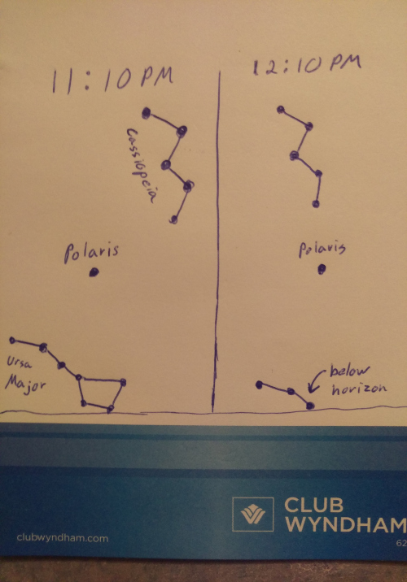

1. When you tie a necktie, and have to make several attempts to get it right (in terms of length), how fast does the error in length converge in terms of number of attempts and the residual error?

For myself, there is rarely convergence… There are probably more methodical ways to putting on a tie that I should follow (eg. actually taking note of the starting length of the tie and adjusting accordingly).

1. The same question, posed differently: A circuit board has 100 uniformly arranged power lines. If one of these lines is shorted, how many of the lines need to be disconnected in order to localize the fault? Assume that a single bus links the lines together, and this bus can be interrupted in places that disconnect all of the lines to the right of the point of interruption. (This will be explained in class.) What might this have to do with the distance an aircraft must be from a runway before it begins an instrument approach?

Understanding the topology of the wiring would help minimize the possible solutions. However, if all lines are arrange adjacent to one another, I believe one would only need to disconnect two wires at a time on either side of the shorted wire in order to localize the problem. An aircraft may need to minimize the possible errors in its approach by converging on the correct path through a binary search.

1. What is the relationship between a nautical mile and the circumference of the earth? How does this relate to a statute mile? Is there an analogous situation for how time is defined (seconds as part of a year, as opposed to seconds as a prescribed number of atomic vibrations)? What is a "knot" in terms of speed?

Nautical miles are used primarily for navigation and is equal to one minute of latitude (or 1/60th of a full degree of latitude). One nautical mile is approximately 1.1508 statute miles. There is an analogy to seconds where UT1 is base on a universal time correlated to the rotation of the Earth and UTC (Coordinated Universal Time) is based upon the atomic vibrations of a cesium 133 atom. A knot is equal to one nautical mile per hour (exactly 1.15078 miles per hour).

1. Is the earth spherical? What common mathematical technique used by electrical engineers to model perturbations to the earth’s gravitational field that result from deviations from the earth’s being a perfect sphere?

The earth is not perfectly spherical because of the many mountains and valleys. If I had to guess I would say engineers use some kind of acoustical tool to identify varying density levels in the Earth’s crust which could cause perturbations in the gravitational field.

1. Who are July and August named after? What are the other months named after?

The Romans named the month of July after Julius Caesar and August after Augustus Caesar. The other months were named after various Roman and Greek gods as well as from Latin derivations, in most cases meaning, “the nth month of the early Roman calendar.”

1. Why does an aircraft, in general, not point the direction in which it is flying?

I believe this is because of the curvature of the Earth. Over a curved surface, the shortest distance is a curved path.

1. When landing an aircraft, what does a pilot do to eliminate the crab angle?

The pilot will use the rudder control the yaw of the aircraft as it is landing. Crab angle can occur do to crosswinds during landing. The pilot must compensate the plane’s yaw in order to keep the plane’s course aligned with the track.

1. What colors are the navigation lights on an airplane?

Their colors are Green and Red from aircrafts. Coincidentally, pilots may not be colorblind in order to fly and red-green colorblindness is the most common type.

1. What is a "coordinated turn" in an aircraft?

A coordinated turn is a maneuver in an aircraft which involves the rudder. The rudder it used to compensate for the adverse yaw created as a result of the aileron creating the needed bank for the turn.

1. Why can't you see Orion in July?

Due to the rotation of the Earth around the Sun, Orion is located in the daytime sky in the Summer which you cannot see in the Northern Hemisphere.

1. What is the Zodiac?

It is list star constellations, whose names are based upon Greek and Roman mythology. Navigators back in the day used these constellations for navigation and tracking purposes.

1. What effect was measured to obtain range information from Sputnik?

Taking an educated guess, I think the radio signals could have been used to identify range. Similar to a standard radar, it would measure the response time of a signal that was sent out of an antenna.

1. How many thunderstorms are there at any given instant on the planet?

According to [www.weatherexplained.com](http://www.weatherexplained.com/) meteorologist estimate that there are roughly 1800 active thunderstorms at any given moment on the Earth’s surface.

1. Have navigation errors been blamed for any major plane crashes?

Without knowing for sure, I would certainly place bets on many plane crashes occurring due to navigation errors. Usually this results in running out of fuel and crashing. Taking Amelia Earhart as an example – her plane presumably ran out of fuel because she and her navigator were running low on fuel and couldn’t properly communicate with ground control.

1. Why do pilots refer to altitudes as "flight levels"?

Below the particular altitude of about 18,000 feet an altimeter needs to be set to its “standard” local barometric setting. Above it is set to 29.92 inches of mercury, the standard barometric pressure setting. Flight levels are used above 18,000 feet.

1. How many stars are considered suitable for navigation?

Of the 57 navigational stars available, I would venture to say only a fraction of these should be necessary for “suitable” navigation. Particularly, if you know where to find Polaris (the northern star) then special techniques can be used in the Northern Hemisphere to determine location.

1. How might cell phones be tracked for purposes of improving the 911 system?

There are two types of location service modes on a phone, “Battery Saving” and “GPS.” If the 911 system could remotely enable the GPS services on a user’s phone then they would have the ability for improved tracking.

1. What general rule of designing a good mathematical algorithm does GPS routinely violate?

A good mathematical algorithm is well understood, reproducible, and deterministic. However, GPS tends to rely on uncertainties in calibrations and clocks which tend to make mathematical algorithms breakdown.

1. Why do navigators like Mercator projections? Why do aviators like Lambeth projections? What is the difference?

Mercator projections use cylindrical latitude parallels which all have the same length as the equator whereas Lambert projections in which the Earth and its parallels are projected onto a cone. Aviators prefer Lambert projections because a straight line drawn on a Lambert projection better approximates a “great-circle” route between endpoints for typical flight distances.

1. What effect do humans use for range-finding?

Humans have two eyes which acts as a disparity for determining distance to an object. The distance between our eyes is more or less hardwired in our brains.

1. Where in the sky and at what time should you attempt to view the planet Mercury?

Mercury is the closet planet to the Sun. Similar to viewing Venus you would only be able to see it during dusk or dawn. It would appear very low on the horizon.

1. Why do the local weather reports include information on tides?

Tides can be linked to standard weather patterns which meteorologist require to predict certain weather phenomenons.

1. Look at the North star, and if visible: Venus, Mercury, Jupiter, its moons, Saturn, and if you have a telescope, its moons. Also plan to look at the International Space Station. Can you see Venus before the sun sets?

I was not able to see Venus before the Sun set. During my stargazing tour in Hawaii, I was able to see Mars, Jupiter and its Galilean moons, Saturn and Titian. It was very interesting to see all the planets follow the ecliptic plane in relation to the constellations positions.